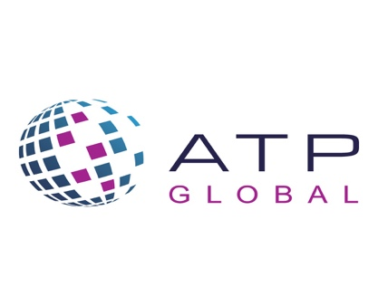
Call for Papers

The Journal of Applied Testing Technology (JATT) is issuing a CALL FOR PAPERS.

JATT is a scholarly online publication that focuses on the role of technology in educational and psychological measurement. Sponsored by the Association of Test Publishers, its goal is to foster scientific dialogue about advances in applied psychometric practice, especially related to the use of technology. Papers are published at no expense to authors and are freely available to the public. The Journal’s intended audience includes practitioners and researchers working in the areas of certification/licensure, clinical, health and public sector assessment, workforce credentialing, educational measurement and industrial-organizational psychology.

Please submit an abstract of 500 words based on either completed or in-progress research, including the expected date of completion of the research by December 1, 2021.

The topics of interest for this special issue include:

- Empirical and practical applications focusing on
- Artificial intelligence (AI) and machine learning in education
- Intelligent learning and tutoring systems
- Learning analytics in K-12 and higher education
- Modeling learning and assessment process data

- Natural language processing (NLP) applications focusing on
- Automated scoring of open-ended questions or essays
- Automatic item and content generation
- Automatic voice or speech recognition

- Ethics of AI
- AI and data privacy
- AI and decision-making processes in education
- Regulatory frameworks on the use of AI in education

We look forward to receiving your submissions for this special issue of JATT. For further information on this special issue or your questions, please feel free to contact Dr. Okan Bulut at bulut@ualberta.ca, Dr. Dianne Henderson at dianne.henderson@act.org, or Holly Garner at holly.garner@kaplan.com.

