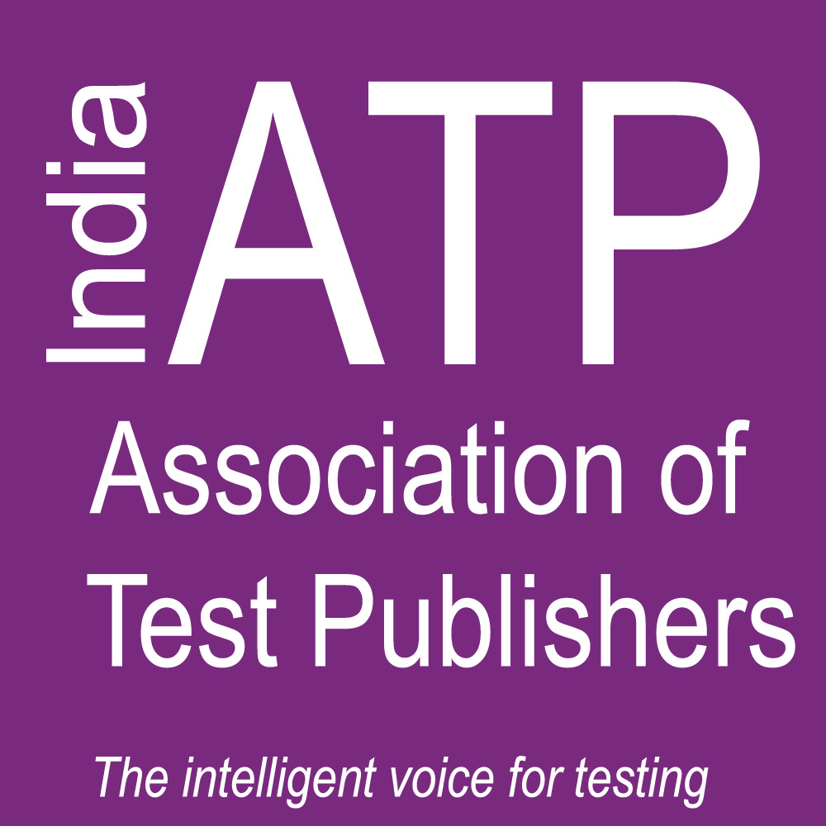
NEWS
_____________________________________________
From the Association of
Test Publishers (ATP)

Contact: Lauren Scheib
+1-717-755-9747 • lauren@testpublishers.org

India - ATP Holds Second Successful Conference in New Delhi
The Future of Higher Education Assessments:
Developing an Ecosystem of Quality Examination

November 9, 2016, New Delhi, India -- “Examinations and assessments have a big role to play in the education system. A sound examination practice is the backbone for determining the outcomes achieved by the education system,” remarked Chief Guest, Prof. Ved Prakash, Chairman, University Grants Commission, New Delhi, as he opened the second annual conference of the Indian Regional Association of Test Publishers (I-ATP), held 9 November 2016 at the Habitat Centre in New Delhi.
“ In the past few decades, there have been conscious efforts to reform the examination system in India. Today, with the advancement of technology and its influence in almost all walks of life, it is important that we re-examine the methods and evolve new models that are relevant not just for today, but also will adapt to the needs to tomorrow,” Prakash noted.
Hosted by I-ATP in academic partnership with The College Board and ACT, the conference drew delegates from more than 50 Universities and Institutes of higher education in India.
"These are leaders and professionals who have a commitment to higher education in India and are interested in what I-ATP has to offer in terms of an assessment community. By joining together at networking events such as this conference, we hope to learn from them as much as we hope to deliver to them in terms of sharing our knowledge and expertise,” stated I-ATP's Regional Director, Soumitra Roy.
Serving as keynote speaker for the event was Dr. C. Peter Magrath, whose extensive higher
education administration experience included serving as head of five major universities in the U.S. Magrath’s speech took a global perspective and focused on the future of world class higher education.
The one-day programme presented informational sessions and workshops on understanding data, the re-design of the SAT, the pervasive use of technology and its impact on testing, and the multi-dimensional problems faced in today's changing international education markets.
ATP CEO Dr. William G. Harris, who also attended the event, noted that India-ATP has continued to progress from a fledgling group a few years ago to a region that has been officially recognized by the Global ATP organization.
"They are a group committed to the mission of ATP and to advancing the assessment industry in a nation whose need for keeping pace with educational innovation is growing rapidly," Harris stated.
Also sponsoring this year’s event was the Graduate Management Admissions Council (GMAC), Internet Testing Systems (iTS), and I-ATP’s founding members: MeritTrac, Pearson Vue and Prometric Testing. Delegates received a Certificate of Completion at the conclusion of the event.
Presentations from the programme will be posted soon on India-ATP’s webpages located at: http://www.testpublishers.org/india-atp-conference.

About ATP and I-ATP

Established in 1992, The Association of Test Publishers (ATP) is an international, non-profit, trade organization representing providers of tests and assessment tools and/or services related to assessment for clinical, occupational, certification, licensing, educational or other similar uses. For more information on ATP or I-ATP visit www.testpublishers.org

The India ATP (I-ATP) is a Regional Division of the Association of Test Publishers that brings together Indian test publishers and related organizations for the purposes of networking, sharing innovative ideas and creating both educational and marketing opportunities related to testing and assessment. Founding member of I-ATP include MeritTrac, Pearson VUE and Prometric Testing.
##

